Auriana Anderson
Jeremiah Lowhorn
DSE6210 Big Data SQL/NoSQL
February 8, 2025
Assignment 4

- Which customer had the most rentals? Return the first name and last name as a single column and the count of rentals per customer in descending order.
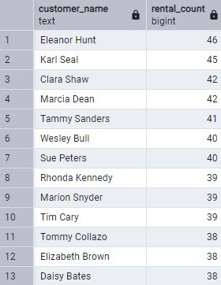
  - Eleanor Hunt had the most rentals which was 46 rentals.
  - select concat(c.first_name, ' ' ,c.last_name) as customer_name,
count(r.rental_id) as rental_count
from customer c
join rental r
on c.customer_id = r.customer_id
group by c.customer_id
order by rental_count desc;
- Did that customer rent any movie more than once? (provide the query to validate)
  - The customer did not rent any movie more than once:
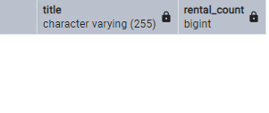
  - select f.title,
count (r.rental_id) as rental_count
from rental r
join inventory i
on r.inventory_id = i.inventory_id
join customer c
on r.customer_id = c.customer_id
join film f
on i.film_id = f.film_id
where concat(c.first_name, ' ' ,c.last_name) = 'Eleanor Hunt'
group by f.film_id
having count(r.rental_id) > 1;
- What is the customer’s favorite movie category? Return the name and the total number of films they have rented in that category.
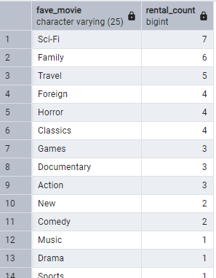
  - Her Favorite movie category is Sci-Fi:
  - select cat.name as fave_movie,
count (r.rental_id) as rental_count
from rental r
join inventory i
on r.inventory_id = i.inventory_id
join customer c
on r.customer_id = c.customer_id
join film f
on i.film_id = f.film_id
join film_category fc
on f.film_id = fc.film_id
join category cat
on fc.category_id = cat.category_id
where concat(c.first_name, ' ' ,c.last_name) = 'Eleanor Hunt'
group by cat.name
order by rental_count desc;
- Write a trigger to delete a customer if they become inactive.
  - DELIMITER //

create trigger remove_inactive_customer
after update on customer
for each row
begin
if New.active = -1 then
delete from customer where customer_id = New.customer_id;
end if ;
end;
//
DELIMITER;
- How can denormalization aid business users answer questions on the database more efficiently? Would it be more advantageous to create a VIEW or to use a NoSQL technology? List the pros and cons of both approaches. Your answer should be a minimum of four paragraphs explaining: how denormalization can help and a comparative analysis of VIEWs vs NoSQL. You will need to perform research online or at the library to answer this question, be sure to cite at LEAST 3 pros and 3 cons for each approach. Cite all sources for your answer.

Denormalization is a process used to reduce the need for complex joins across multiple tables in a database. It is used to reduce costs, however, usually it adds a lot of redundancies into the database. This technique is applied after normalization. It is used to help with the performance of the database for operations that can be time sensitive. This method, however, requires way more storage and may mess with data integrity because of the redundancies that are created during the denormalization process.
Views can be one way to gain the benefits of denormalization because a view is a virtual table. You can maintain the structure of the database without the need for extra storage. The Business users can then use these views to find the information they need through queries. Views are easy to read and interpret, retain data integrity, and are better for the overall database security (because you can lock/hide certain features to certain users). However, if views require complex queries, it can become very slow, hard to update or un-updatable, and changes to underlying tables can impact how the view functions.
A NoSQL approach such as a document oriented one stores related data in a single document whereas of storing normalized data across multiple tables. This allows for faster data retrieval since all the information can be gathered in a single query rather than using multiple joins. This can help businesses gather data fast and efficiently, handle large amounts of data that might not necessarily be structured, and allow for distributed systems to handle large loads of data (ecommerce may do this to handle user traffic). While NoSQL solutions allow for more flexibility, it may create data inconsistency (loss of integrity), every time there are updates, each document of denormalized data needs to be updated as well, and the document structure may start to get confusing after a while. Also to even convert from a SQL based system to a NoSQL system requires huge changes that may take a while to implement.
When we are working with a relational database, views are beneficial especially if we want secure, consistent data access, and need it to be structured but a NoSQL approach might be better if we are looking for optimized efficiency, flexibility, are are dealing with large amounts of data. When deciding it is important to think of the scale of the business operation. My job, a non-profit works best with a relational database and uses views, but something that is larger scale, like Amazon may use a non-relational database approach for its Product catalog look-ups and therefore may use NOSQL.

Reference list
Awati, R., Wright, G. and Vaughan, J. (no date) What is denormalization and how does it work?, SearchDataManagement. Available at: https://www.techtarget.com/searchdatamanagement/definition/denormalization.
Dotnet Tutorial (2021) Dotnet Tutorial, Dotnet Tutorial. Available at: https://www.dotnetustad.com/sql-server/advantages-and-disadvantages-of-views (Accessed: 8 February 2025).
GeeksforGeeks (2018) Denormalization in Databases, GeeksforGeeks. Available at: https://www.geeksforgeeks.org/denormalization-in-databases/#google_vignette (Accessed: 8 February 2025).
Muens, P. (2016) Why we don’t denormalize anymore, Medium. Available at: https://pmuens.medium.com/why-we-don-t-denormalize-anymore-dc58b898765c.

